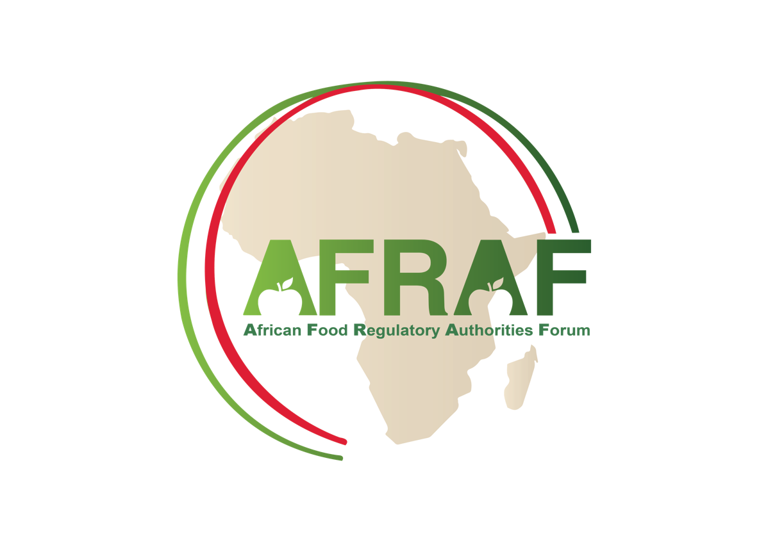

High Level Senior Food Regulators Meeting of
African Food Competent Authorities

Towards Collaborative African Food Regulatory Frameworks,
Supporting the Implementation of the Africa Food Safety Strategy (AFSS)

CHARTER

October 2023

Contents
1. Background and Rationale 3
2. Objectives of the AFRAF 4
3. Membership 4
4. Meetings of the AFRAF 5
5. Forum Steering Committee Designation and Operations 6
6. Votes 6
7. Work Management and Other Considerations 7
Annex I: Members of the African Food Regulatory Authorities Forum 8

Background and Rationale
Food safety and nutrition are key determinants of health and human development. Food regulatory decisions have far-reaching implications on the health, agriculture and trade agendas for any given country, both domestically and at the international level.
Africa’s contribution to the global food and agrifood supply is increasingly important, considering the important water and land resources afforded by the continent. African countries are demonstrating increasing commitment to modernizing and further enhancing their agricultural output and their food and agrifood production, with opportunities of development that can have important positive impacts on the economies of African countries and the continent.
Producing safe and nutritious food for Africa’s population and increasing intra-regional trade of food and agrifood products within the African continent were also identified as some of the objectives pursued by the African Continental Free Trade Agreement (AfCFTA) launched in 2021.
In recent years, African leaders have prioritized actions in relation to food safety and SPS matters in an effort to address some of the public health and economic challenges. Several discussions have taken place on the possibility of establishing a unified food safety agency for the continent, sharing a common SPS policy framework and with the dual objectives of harmonizing SPS measures and supporting a common approach to food safety capacity building across the African continent (AUC, 2019; WTO, 2019).
Many changes are being witnessed in the African food safety regulatory context, with the development of new food competent authorities and agencies entrusted with the overall food safety regulatory mandate, such as the creation of the Food Safety and Quality Authority of the Gambia, the National Food Safety Agency of the Arab Republic of Egypt (NFSA) and similar agencies established in Nigeria, Ghana, and Mauritania.
These changes, along with efforts of coordination and food regulatory convergence led by African Regional Economic Communities (RECs), such as ECOWAS and EAC, would benefit from the creation of a favourable collaborative environment between African food regulators, through the development of an African Food Regulatory Authorities Forum (AFRAF), under the leadership of the African Union Commission, its specialized departments and in partnership with the RECs.
This direction is further supported by the outputs of 36th Ordinary Session of the African Union Assembly of Heads of State and Government, held on 18-19 February 2023 in Addis Ababa, Ethiopia identifying the priority of the year as being “Accelerating the Implementation of the Africa Continental Free Trade Area” and highlighting the importance of the food and agrifood sector in the intra-continental trade.
The potential for growth of this segment of intra-continental trade is estimated to be exponential and needs to be further driven by enhanced alignment of African food regulatory frameworks, which requires the development of the relevant forum for Dialogue and collaboration between African Food Regulators.

Recognizing that collaboration between food competent authorities is imperative to address an increasingly complex and interdependent health, food production and food trade environment, food competent authorities in Africa supported by international partners, decided to convene a network of African food competent authorities at the heads of authority level, with the aim to facilitate engagement and discussions amongst leaders of African food regulatory authorities.
This network will be known as the African Food Regulatory Authorities Forum or AFRAF, identified further in this document as The Forum.

Objectives of the AFRAF
The AFRAF aims to:
- Serve as an information exchange, experience sharing and collaboration development Forum, between food competent authorities of countries of the African Union, joining the Forum.
- Shape an agenda of collaborative initiatives to contribute to the development of a path forward for African food regulatory harmonization and integration as part of the implementation of the African Continental Free Trade Area (AfCFTA) and to address common challenges faced by African food competent authorities and the food and agri-food production sector.
- Contribute to the delivery of commitments of the Food Safety Strategy for Africa (FSSA) - 2022-2036, through supporting the operation of a science-based and efficient food regulatory environment in Africa leading to delivering “safer agrifood value chains across the continent, reduced foodborne disease burden in Africa, improved competitiveness of Africa’s food commodities for increased intra-African and global trade.”
- Develop a foundation for the governance structure of the soon to be established African Food Safety Agency (AFSA).

Membership
- Any organisation from a Member State of the African Union, considered to be a competent authority, with food regulatory oversight may be admitted as a member of the Forum.
- For Member States of the African Union, where several food competent authorities share the responsibility of food regulatory oversight, competent authority members of the Forum will coordinate their positions and interventions,

- The African Union Commission represented by the Department of Agriculture, Rural Development, Blue Economy, and Sustainable Environment is a permanent member of the Forum.
- Founding members of the forum are food competent authorities represented at the inaugural meeting of the Forum held from 11-13 October 2023, hosted by the National Food Safety Authority of the Arab Republic of Egypt (NFSA).
- A Food competent authority, from a Member State of the African Union may apply to join the Forum and is admitted upon endorsement by the existing membership of the Forum based on the recommendation of the Forum Steering Committee.
Annex I offers a record of food competent authorities that are part of AFRAF at a given date. The list of participating authorities will be maintained and updated on a regular basis, based on the admission of new members.
Members of the forum express their commitment to the development of the agreed upon collaborative agenda by actively participating in the Forum activities. The absence of a member from three (3) consecutive virtual meetings will be considered as a forfeiture of the membership into the Forum.
A country may apply to be a member of the Forum through a submission made by the relevant food competent authority to the Secretariat of the Forum defined in Paragraph 5.

Meetings of the AFRAF
- The Forum will hold at least two virtual meetings annually, hosted by one of its members, generally the member acting as the Chair of the Forum.
- It is recommended that a physical or a hybrid meeting of the Forum be held on a Biennial basis.
- During a meeting of the Forum, each member’s delegation may be composed from 1-3 participants of senior officials, including the head of the agency / department.
- Each meeting of the Forum will include a high-level exchange between senior regulators focused on the themes proposed and identified of importance by participating authorities.
- Each meeting of the Forum will strive to drive forward the implementation of possible recommendations for opportunities of collaboration, sharing experiences and the collective work agenda in a given priority area.
- Virtual meeting duration will vary between 1-3 hours based on the requirements of the agenda.
- Meetings will be chaired by the senior representative of the authority Chairing the Forum, during a given period.
- Members of the Forum will reach their conclusions and recommendations by consensus, facilitated by the Chair.
- If consensus is not reached on a given resolution, requiring a decision, a vote with a simple majority could be called by the Chair to determine the outcome of the said resolution.
- Each member organization will strive to fund its participation to the activities of the Forum.
- Forum members may mobilize additional resources to support participation of some other members into the Forum, as may be possible.
- Where required, working groups, task teams or ad hoc committees can be created to work on delivering some activities and outputs agreed to by African heads of food competent authorities.
- Agendas of meetings, whether physical, virtual or hybrid are to be prepared by the secretariat of Forum, hosted by the Chair country, and shared with all members, at least one week before the meeting. Agenda items can be suggested by any member of the Forum and considered for inclusion, as part of the discussions planned.

Forum Steering Committee Designation and Operations
A steering committee made of five countries representing the five AU regions and their associated food regulatory authorities will be created to offer executive leadership and management of the activities of the Forum.
The five countries will be elected during a meeting of the Forum, using a simple majority vote. A quorum of 30% of countries represented in the Forum is required for votes related to the appointments of the members of the Steering Committee.
The African Union Commission, through the Department of Agriculture, Rural Development, Blue Economy, and Sustainable Environment will appoint a permanent representative of the AUC, as a voting member of the Forum Steering Committee.
The tenure of the Steering Committee is three years.
There is no limitation in the number of tenures served by a member of the Steering Committee.
The Steering Committee will be responsible for overseeing the activities of the Forum, their planning, and their implementation, including the organisation of meetings of the Forum.
The Chair of the Steering Committee is elected amongst Steering Committee members, by the entire membership of the Forum. The Chair will serve during the same tenure of the Forum Steering Committee.
The competent authority serving as the Chair of the Forum will host and manage the secretariat of the Forum.

Votes
- Members of the Forum will strive to reach their conclusions and recommendations by consensus, facilitated by the Chair.
- If consensus is not reached on a given resolution, requiring a decision, a vote with a simple majority could be called by the Chair to determine the outcome of the said resolution.
- A quorum of 30% of countries represented by the Forum is required for votes.
- Countries where multiple competent authorities share the responsibility of food regulatory oversight and are members of the Forum, will determine their vote through internal coordination between the competent authorities represented in the Forum (1 country, 1 vote).

Work Management and Other Considerations
- The Forum may develop an agenda of collaborative work between some or all of its members. Work items will be managed in a transparent and inclusive manner.
- Where required, task teams or working groups can be created to facilitate delivery on some outputs agreed upon by Forum members. Participation to such working groups is voluntary, and is the responsibility of each organization. Each task team or working group leader will strive to maintain a transparent and inclusive approach in the conduct of the agreed upon tasks
- The Forum is meant to complement and enable additional support for international collaboration between food regulatory authorities in Africa, in a manner that may bolster the Program and the development of international standards under the auspices of the Codex Alimentarius Commission (Codex / CAC), among others.
- The Forum will embrace Codex Values of transparency, inclusiveness and collaboration in all of its proceedings

Dated / Last amended on:

Annex I: Members of the African Food Regulatory Authorities Forum
Date: xxxxxxxxx

